**Final Code for Statistical Analysis 2018**

**Super Site Distinctions:**

* **Marta:** Marta, Copal, Pejibaye
* **Tapanti:** Tapanti, Villa Mills
* **Savegre:** Savegre Valley
* **ASBC:** ASBC, Bosque de Agua, Yorks Nubes
* **Chirripo:** Chirripo
* **Cabo Blanco:** Cabo Blanco, PNLC, PN Carara
* **Osa:** Osa Campanario
* **PILA:** PILA

**Code: Creates a column in data frame of inputted data the contains super site designation**

ind.data["SuperSite"] <- ifelse(ind.data$Site == "Marta"|ind.data$Site == "Copal"|ind.data$Site == "Pejibaye", "Marta", ifelse(ind.data$Site == "Tapanti"| ind.data$Site == "Villa Mills", "Tapanti", ifelse(ind.data$Site == "Savegre Valley", "Savegre", ifelse(ind.data$Site == "ASBC"|ind.data$Site == "Bosque de Agua"|ind.data$Site == "Yorks Nubes", "ASBC", ifelse(ind.data$Site == "Chirripo", "Chirripo", ifelse(ind.data$Site == "Cabo Blanco"|ind.data$Site == "PNLC"|ind.data$Site == "PN Carara", "Cabo Blanco", ifelse(ind.data$Site == "Osa Campanario", "Osa", ifelse(ind.data$Site == "PILA", "PILA", NA))))))))

**Lunar:**

* **Final Code for Lunar:** runs confidence intervals (estimate, lower, and upper), Watson statistic, W statistic, and Chi-Squared statistic for predator-prey pairs. Also generates overlap plots for pairs.
  + Directions for Manipulating Code:
    - If changing number of bootstraps: change line 416 overall(pair, numboot = #)
    - If changing which tests are run: comment out call to functions in overall function beginning line 360 and beginning line 388 that binds test outputs in overall function (statistics <- cbind())
    - If generating plot, change folder location line 381 and file location line 383
    - If want to calculate only a select number of pairs, change the species in prey and predator lists in lines 405 and 406
  + Has comments printed after each pair done so progress can be tracked
  + 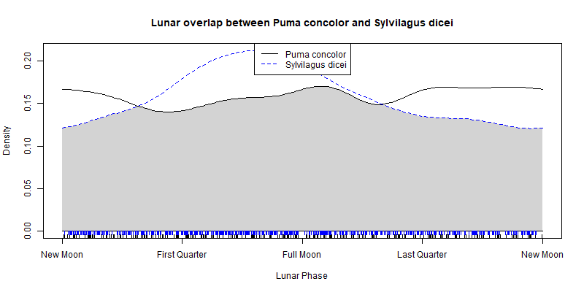Creates Plots as below:

**Activity:**

* **Final Code For Statistics on Activity:** runs confidence intervals (estimate, lower, and upper), Watson statistic, W statistic, and Chi-Squared statistic for predator-prey pairs. Also generates overlap plots for pairs (although duplicates are removed so plots for all possible pairs with each species are not in each species’ folder. Recommended to use Code to Generate Plots on All Pairs with Duplicates)
  + Directions for Manipulating Code:
    - If changing number of bootstraps: change line 419 (numboot = #)
    - If changing which tests are run: comment out call to functions in overall function beginning line 364 and beginning at line 380 to bind the test outputs in overall function (statistics <- cbind())
    - If generating plot, change file location (line 375) and folder name (line 373)
  + Has comments printed after each pair is done so progress can be tracked
  + Has code to remove duplicates (puma-agouti and agouti-puma) and doubles (puma-puma)
* **Code to Generate Plots on All Pairs with Duplicates:** plots put into folders by species so all possible pairs within each species’ folder
  + Has code to remove doubles

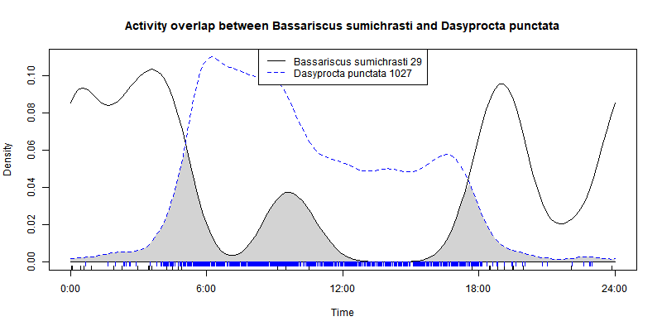Creates plots below:

**Relative Abundance**

* **Code to Generate RAI:** Calculates relative abundance for every species observed at each supersite as well as overall
* **Code to Generate Lunar EstimatexRAI:** Calculates estimate and multiplies by relative abundance of second in pair for every species pairs (doubles (puma-puma) removed)
* **Code to Generate Circadian EstimatexRAI:** Calculates estimate and multiplies by relative abundance of second in pair for every species pairs (doubles (puma-puma) removed)

**Mixed Models -using likelihood ratio test**

**\*All lmer code returns AIC, BIC, Pr(>Chisq)**

* **Lmer code for circadian for specific prey:** Calculates mixed model suitability comparing prey abundance as well as prey abundance multiplied by mass and circadian activity of predator with site as a random factor
  + Calculates RAIxMass - line 54 has data.frame prepared to print out for all pairs
  + Currently cannot run on oncilla because not enough observations to calculate estimate on any supersite except for overall
* **Lmer code for lunar for specific prey:** Calculates mixed model suitability comparing prey abundance as well as prey abundance multiplied by mass and lunar activity of predator with site as a random factor
  + Calculates RAIxMass - line 55 has data.frame prepared to print out for all pairs
  + Currently cannot run on oncilla, jaguar, and tayra because not enough observations to calculate estimate on any supersite except for overall

**Sample Size**

* **Code to calculate number of observations per species per Site:** 
  + Super Sites different than main defined at top, rather defined by trail and Site (used *Site* and Group 2 in Data):
    - **Quetzales:**  Campamento, Lagos, Las Vueltas, Ojo de Agua, Chanchos, Torres
    - **Rio Savegre:** Dantica, Robles, Quedrada, Cumbre, Manantial, Sendero de la Danta, Finca, Cataratas, La Lira, Waterfall
    - **ASBC:** *ASBC*, Los Cusingos
    - **Los Cusingos:** Los Cusingos
    - **Tapanti:** *Villa Mills, Tapanti, Yorks Nubes*
    - **Bosque de Agua:** *Bosque de Agua*
    - **Cabo Blanco:** *Cabo Blanco*
    - **PN Carara:** *PN Carara*
    - **Osa Campanario:** *Osa Campanario*
    - **Chirripo:** *Chirripo*
    - **PILA:** *PILA*
    - **PNLC:** *PNLC*
    - **Marta:** *Marta*
    - **Copal:** *Copal*

**Further Activity Plots:**

* **Code to generate plots of activity for each species to compare season and site foldered by site:** creates plots as below for each site of each species, a line for each season (Winter, Spring, Summer, Fall) and overall. Season determined by month: Winter = January, February, March; Spring = April, May, June; Summer = July, August, September; Fall= October, November, December)
  + Directions to manipulate code:
    - Change input and output file and folder names: data in line 8, folder in line 121, folder in line 123

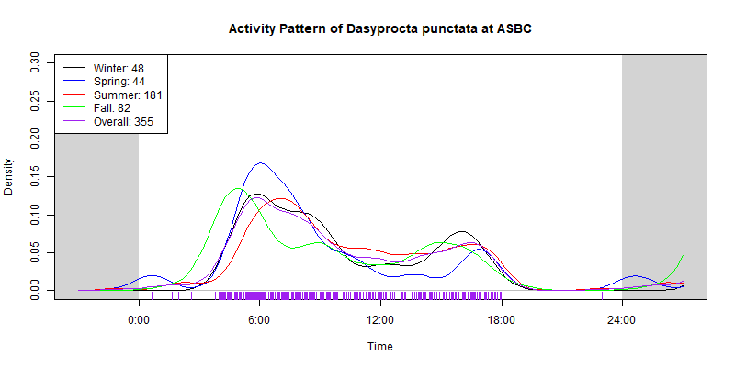

* **Code to generate plots of activity for each species at each binned location:** creates plots as below for each species with a line per super site
  + Directions to manipulate code:
    - Change input and output file and folder names: data in line 9, plot file in line 150

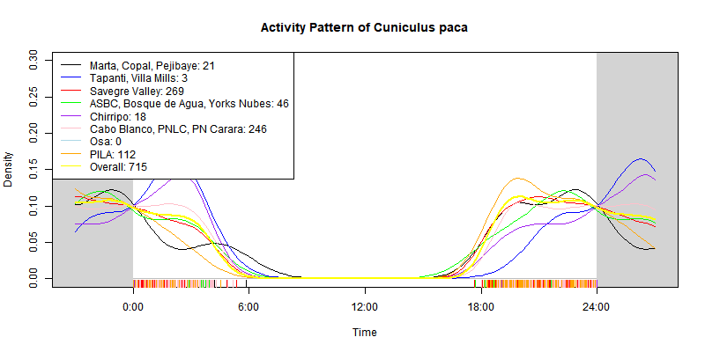

* **Code to generate plots of activity for each species to compare season and site foldered by species:** creates matrix of plots as below for each species, with plots for each site (not binned) with a line for each season
  + Directions for manipulating code:
    - Change data file name in line 8, plot file name in line 122

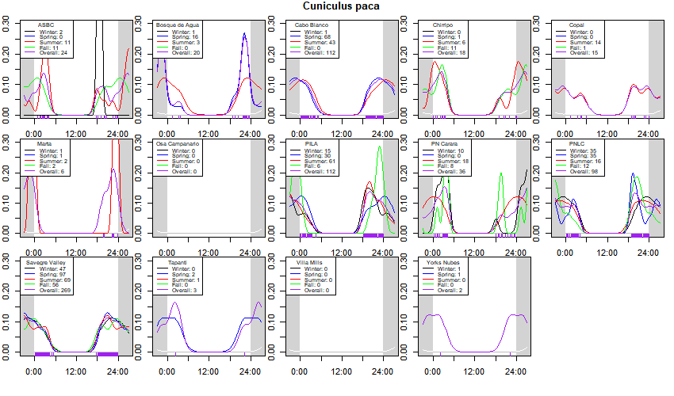

* **Activity Code to generate plots of each predator by site:** creates plots like below that show activity of the main predators (Panthera onca, Puma concolor, Canis latrans, Leopardus pardalis, Leopardus tigrinus oncilla) at each site
  + Directions for manipulating code:
    - 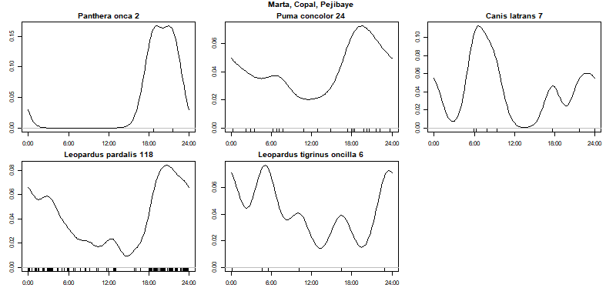Change data filename in line 9, species in namelist if change in line 28, plot folder names in line 129, 139, 149, 159, 169, 179, 189, 199, 209
* **Activity prey code to generate plots of each predator and main available prey at each site:** generates plots as below for main predator species (Panthera onca, Puma concolor, Canis latrans, Leopardus pardalis, Leopardus tigrinus oncilla). Prey is not specific to predator.
  + Directions for manipulation of code:
    - Change **data filename in line 10**, species in namelist if change in lines 30 and 31, species in legend if change in lines 241, 262 283, 303, 323, 343, 363, 383, **plot folder names in lines 227, 248, 269, 289, 309, 329, 349, 369**, **plot file names in lines 231, 252, 273, 293, 313, 333 353, 373**

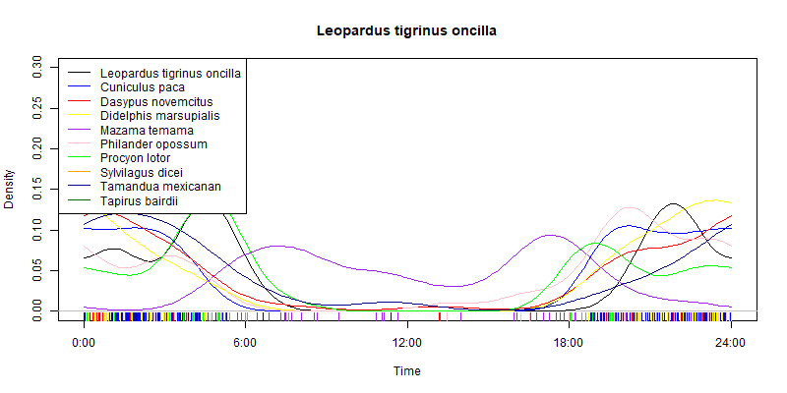

* **Activity of each predator and specific prey per supersite:** Plots relationship of predator and their specific prey at each supersite on same plot
  + Directions to manipulate code:
    - 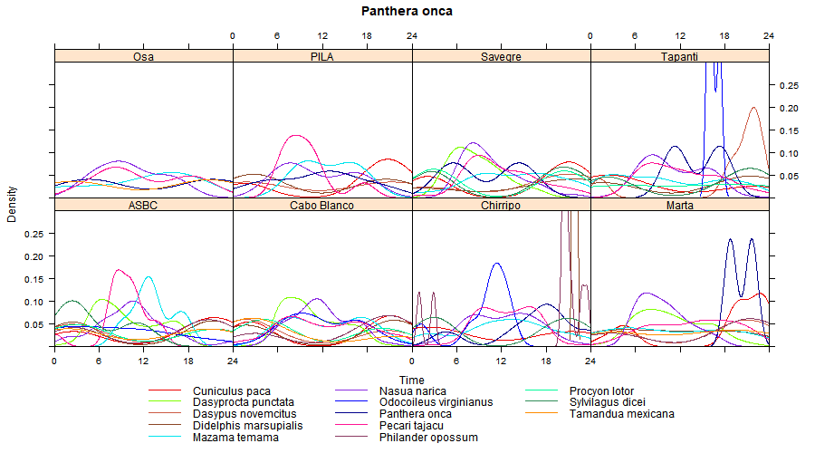Change data filename in line 12, specific prey species if change in lines 35, 37, 39, 41, 43, 45, plot file names in lines 73, 78, 83, 88, 93, 98
* **Code to generate plots of circadian activity of each main prey species with main predator species:** creates plots as below to compare prey activity with predator activity. Two plots generated per species: one is only the activity of the prey species, the second includes the predator species’ activity
  + Directions to manipulate code:
    - Change data filename in line 15, species in namelist if change in lines 10 and 11, plot file names in lines 49, and 55

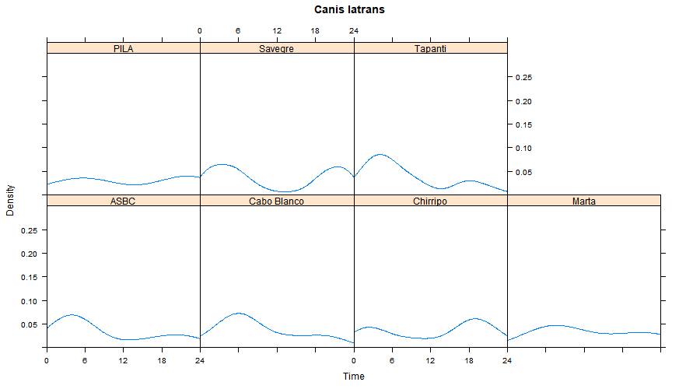

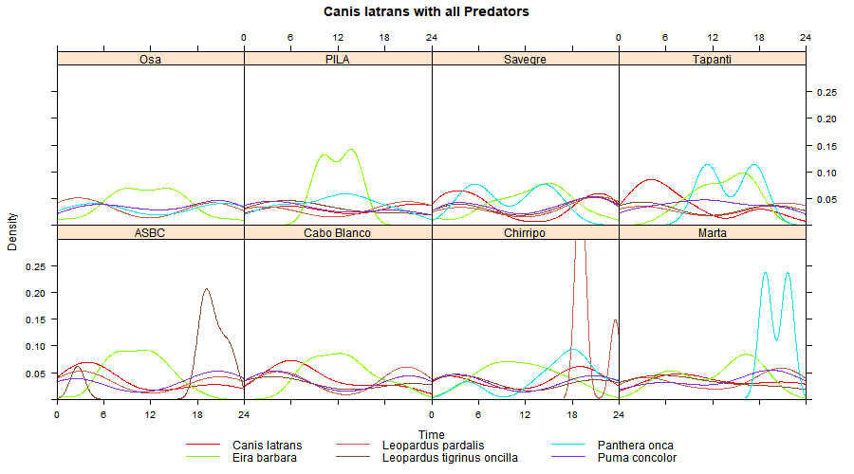

* **Code to generate plots of circadian activity comparing main predators at each site:** creates matrix per predator species (Panthera onca, Puma concolor, Canis latrans, Leopardus pardalis, Leopardus tigrinus oncilla, Eira Barbara) of plots for each binned supersite. Also creates a matrix of plots per binned supersite with lines for each predator
  + Directions to manipulate code:

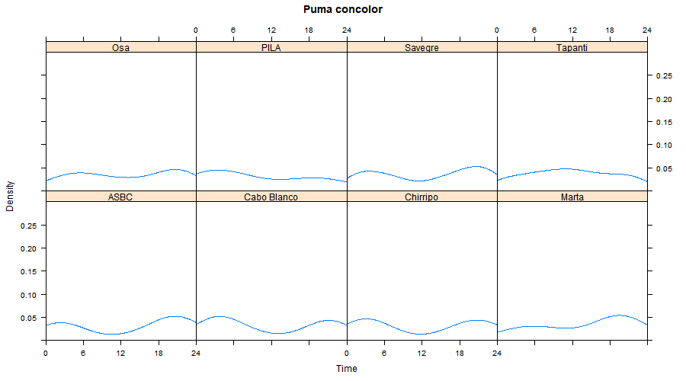

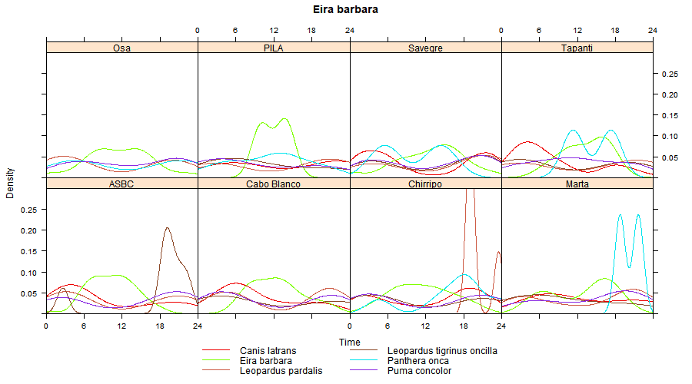

* **Code to generate plots of Circadian Activity of all specific prey species compared to predator:**  creates matrix as below of plots that show circadian activity of main predators (Panthera onca, Puma concolor, Canis latrans, Leopardus pardalis, Leopardus tigrinus oncilla) with each specific species

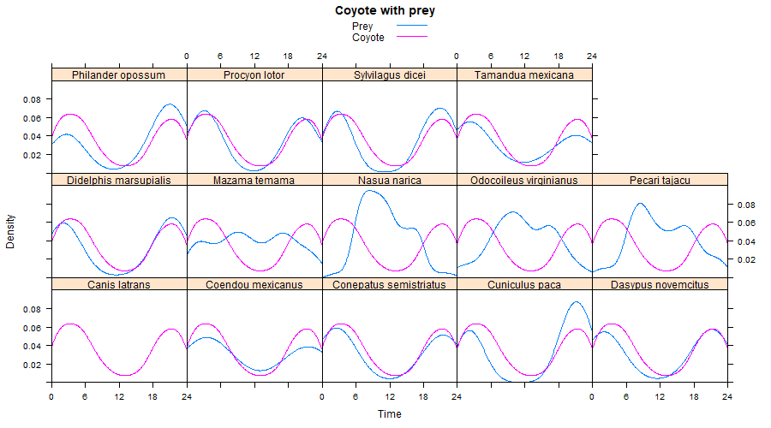

**Further Lunar Plots:**

* **Code to generate plots of lunar for each species at each binned location:** creates matrix of plots as below of lunar activity at each super site for each species individually. Only species designated as nocturnal included.
  + Directions to manipulate code:
    - Change data file name in line 9 and plot file name in line 137
    - If species name changes or want to include different species names: change species in namelist in line 131

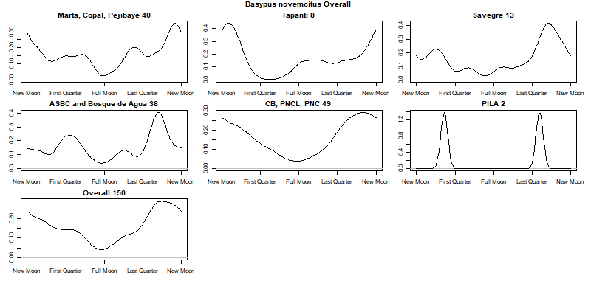

* **Code to generate plots of lunar for each species to compare site and season:** creates matrix as below of plots for each species at each site (not binned), each plot within matrix a season
  + Directions for manipulating code:
    - 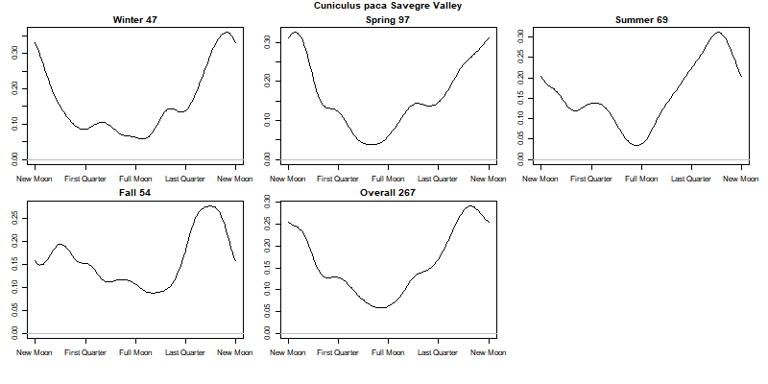Change data file name in line 10, species if change in line 120, plot folder names in line 131 and plot file name in line 136
* **Lunar Code to generate plots of each predator by site:**  creates matrix as below of plots that show lunar activity of main predators (Panthera onca, Puma concolor, Canis latrans, Leopardus pardalis, Leopardus tigrinus oncilla) at each site
  + Directions for manipulating code:
    - 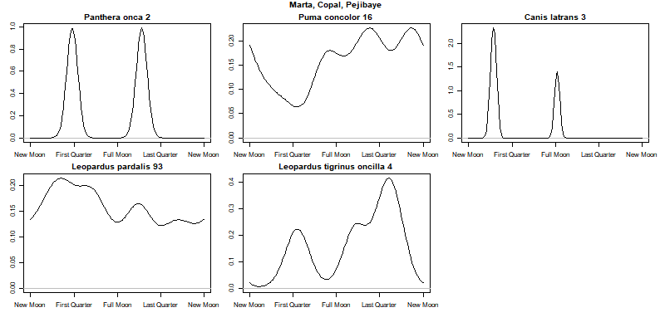Change data filename in line 9, species in namelist if change in line 27, plot folder names in line 136, 146, 156, 166, 176, 186, 196, 206, 216